Employee Self Service– the url is: <https://ess.eips.ca/essHR>

If you are not at an Elk Island school or site, you will be prompted with ‘Sign in with your organizational account’. You will need to enter educ\username and your network password

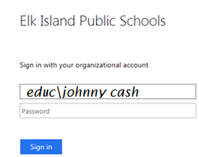

The second login is employee number and ESS password. On your first time entering this site, you will not have a password and will have to click on Forgot Your Password to reset it yourself.

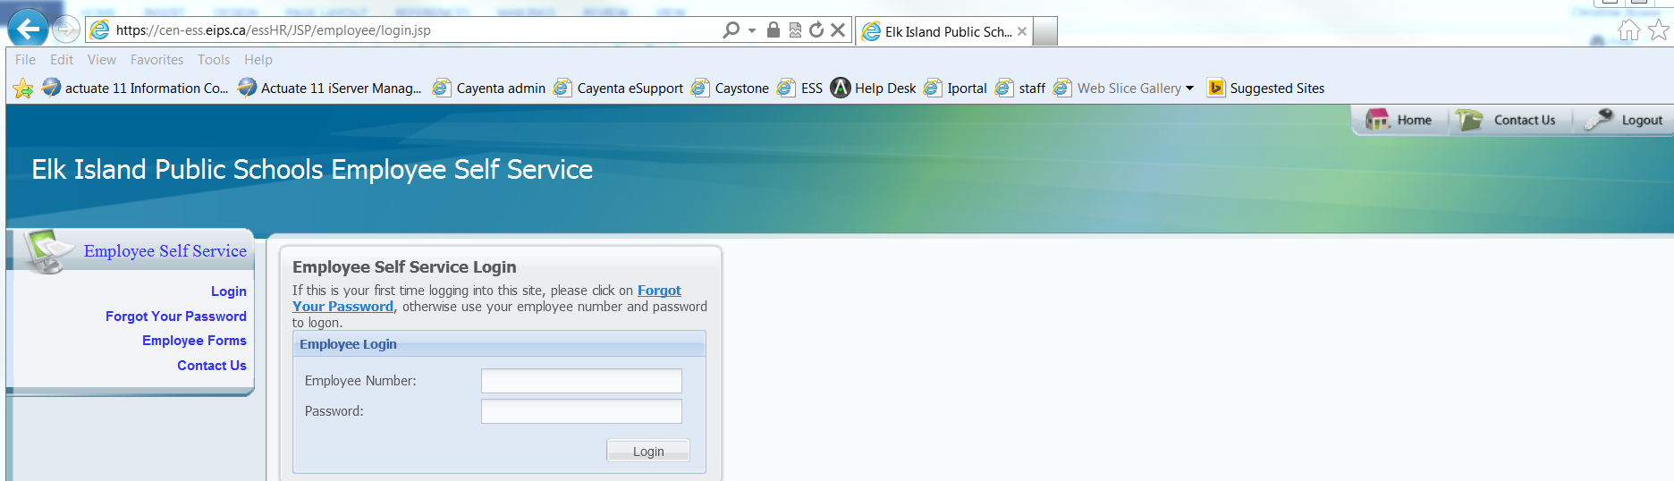

If you don’t have a password, you can click on Forgot Your Password and reset it yourself.

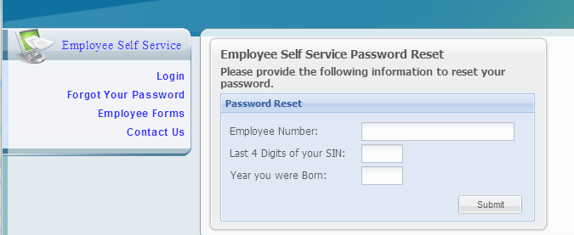

Once in, you can access cheque history to get your pay stub.

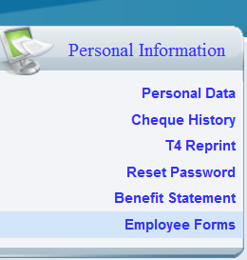

Once your password is reset, you will be able to logon using your **employee number** and new **password**

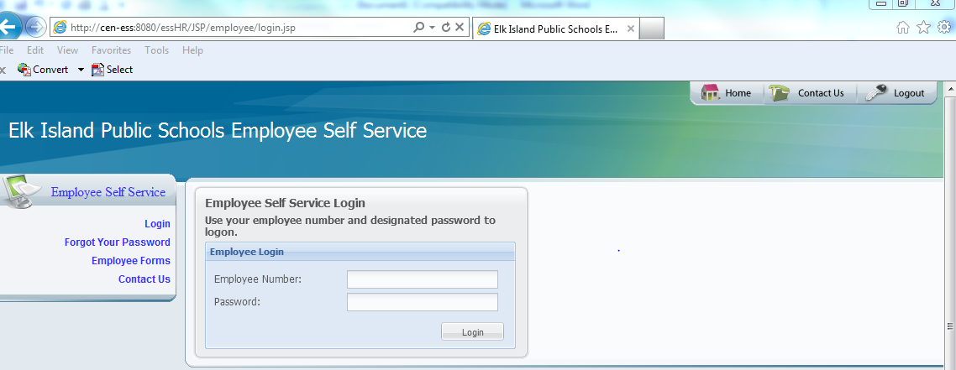

The only available options at this time are Personal Data, Cheque History, T4 Reprint and Reset Password

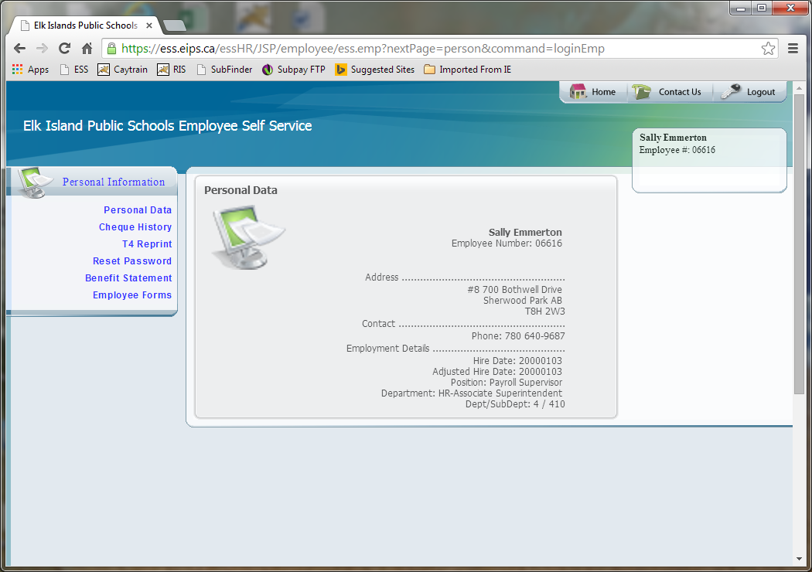

When you select Cheque history, you will see the following:

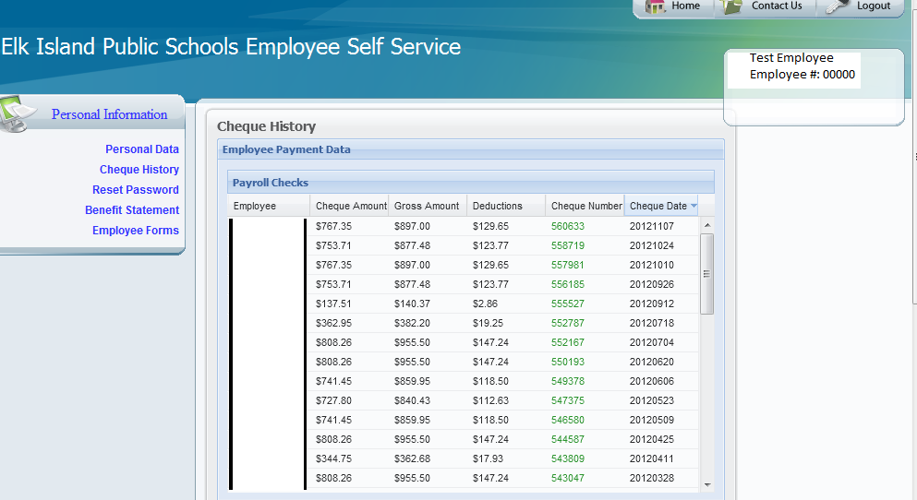

You can click on any of the cheque lines to access the details of that cheque.

Please click on Logout when you are done.